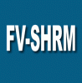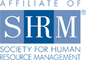
Meeting Notice: May 9, 2013
Flathead Valley Chapter of
Society for Human Resource Management

We are looking forward to seeing you at our upcoming meeting!
RSVP required. Please RSVP by NOON on Monday, May 6 to our Treasurer, Ronda Gress, at ronda@completerestorationllc.com. Please advise if you wish to order lunch or not when you RSVP.

Date: Thursday, May 9, 2013
Program: Legislative Update
Presenter: Jim Nys, Personnel Plus!
Time: 11:30 a.m. to 1:00 p.m. NOTE OUR MEETING TIME: Lunch will be served at 11:30 and our general meeting
will start at 11:45 a.m.
Place: Hilton Garden Inn, 1840 US Hwy 93 South, Kalispell
Lunch: MEMBER: No charge for members.
NON-MEMBER: $24 for program & lunch for non-members.
Note: Non-members who RSVP for lunch and are unable to attend will still be billed.

Program Description: Jim Nys will provide an overview and summary of the current legislative topics relating to Human Resources from the state and national levels. Attendees will learn how the proposed bills may change how we conduct Human Resource Management in the state of Montana, as well as how the bills and trends affect their organizations. This knowledge is essential for HR professionals to assist their organization in strategic planning and to influence the fate of these bills. Included in his presentation will be updates on employment law, contact information for Montana legislators, and a review of the trends he is seeing as he is called to serve as an expert witness in litigation.

Presenter Information: Jim Nys, PHR, DTM, MPA is the President and Chief Human Resource Management Consultant for Personnel PLUS! Consulting Services, Inc. Jim has over 30 years experience in public and private personnel management. Nys holds a Masters Degree from the University of Montana. He also serves as an expert witness in employment litigation matters. Nys has been appointed to three National Committees of SHRM. Jim has lobbied on behalf of small business for the NFIB, The Montana Chamber of Commerce and the HR profession since 1983.

We encourage Flathead Valley Chapter members to bring guests to our monthly meetings to experience first hand, the benefit of SHRM. Members who bring guests will have an opportunity to win a lunch redeemable at a future meeting.

Don’t forget to bring CASH!
Support the SHRM Foundation and yourself — buy “Split the Pot” tickets! YOU could win money!

Visit our website at http://flathead.shrm.org/ for more information about our upcoming events and legislative updates!

Connect with other members online in our LinkedIn Group:
http://www.linkedin.com/groups/SHRM-Flathead-Valley-Kalispell-Montana-4286381?trk=myg_ugrp_ovr.

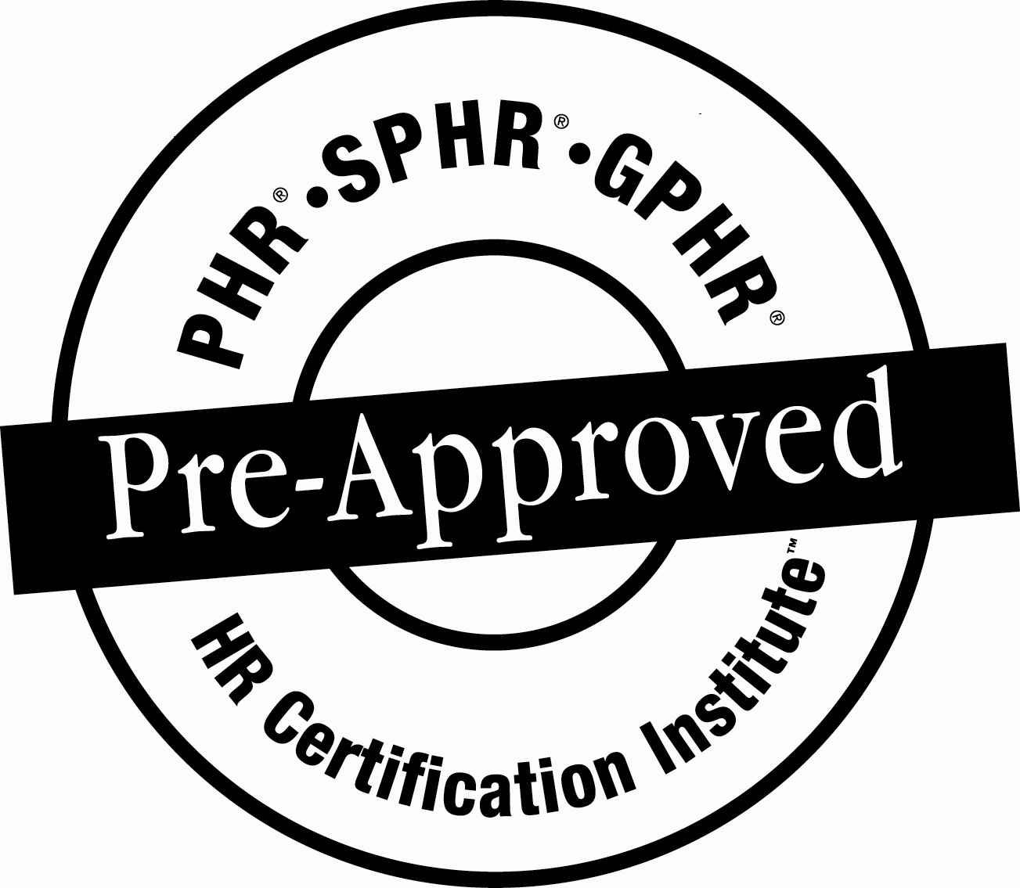
*The use of the HRCI Pre-Approved seal is not an endorsement by the HR Certification Institute of the quality of the program. It means that this program has met the HR Certification Institute’s criteria to be pre-approved for recertification credit.

